**PROJECT TITLE:**

**Front End Project For Eunimart**

**Project Manager(s):**

**Bachu Sathvik Kumar(19H61A1204)**

**Project Summary**

* In the home page we need to show the list of user cards and when the user clicks on any card we need to show particular user details with routing.
* 1) Create 2 components, one is the user's home page and another one is user details page.
* 2) create 2 routes for 2 components. list page routing http://localhost:3000/users, user details page [http://localhost:3000/users/{userid}](http://localhost:3000/users/%7buserid%7d)

I have spent lot of time to complete this project. This project helped us to experience the real time scenarios.

I have got good experience with this….

This project is done by Using React JS & CSS.

Home page is as Follows:

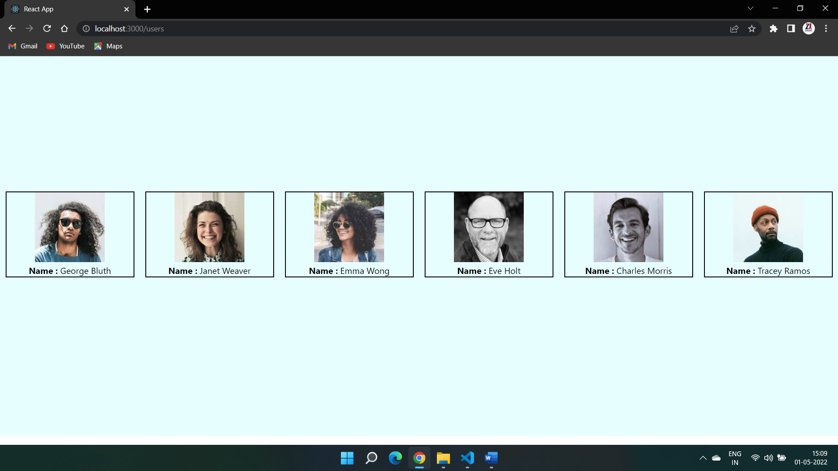

As we click on any particular card we will get the details as shown.

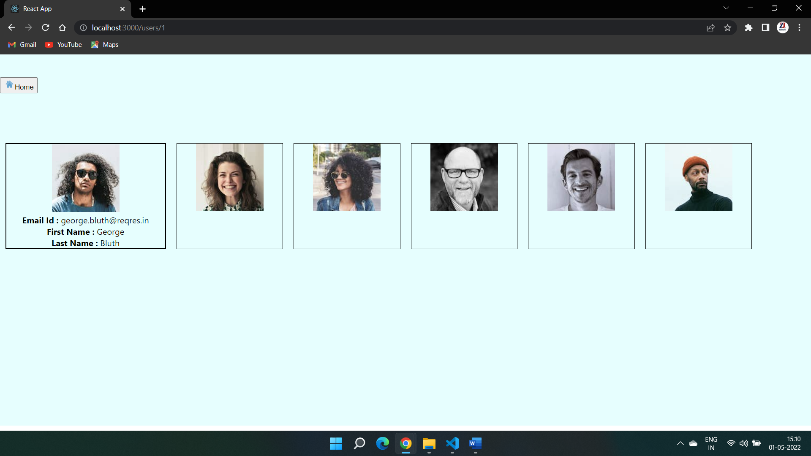

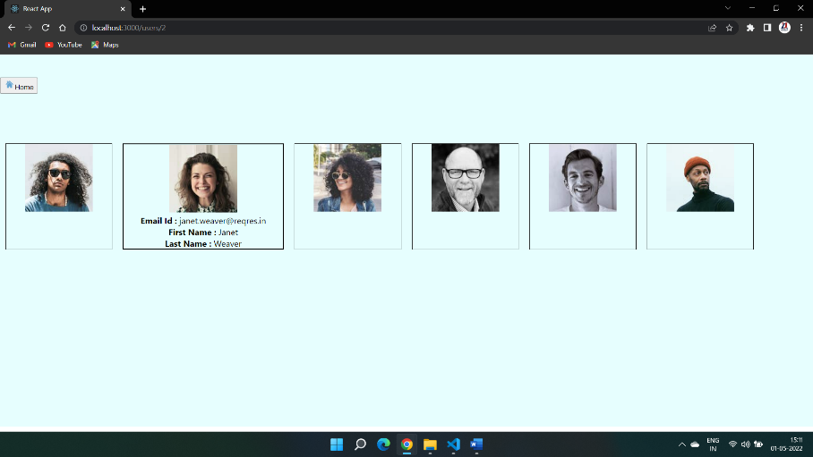

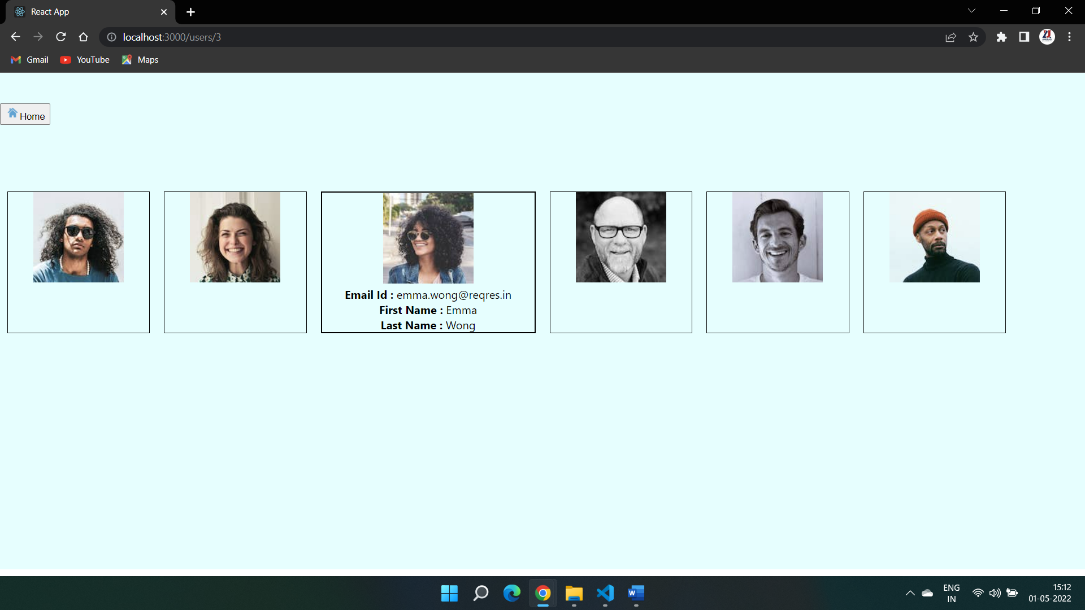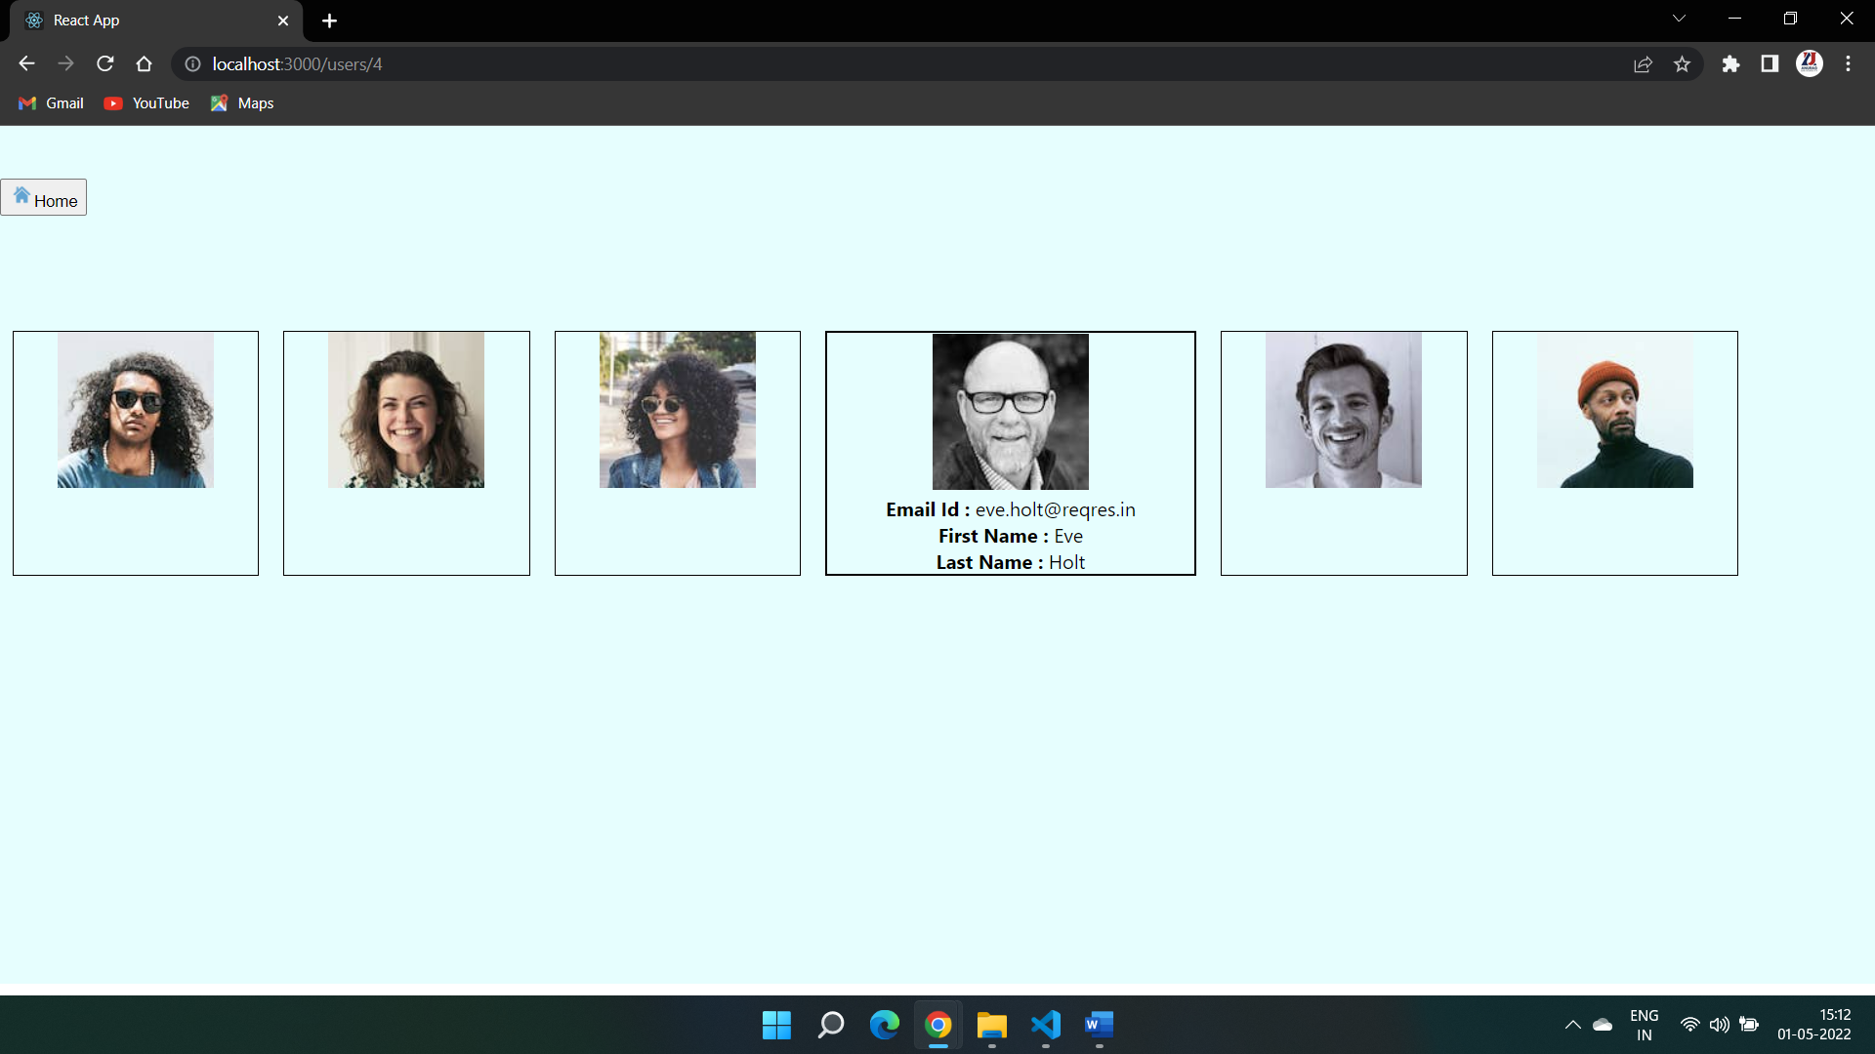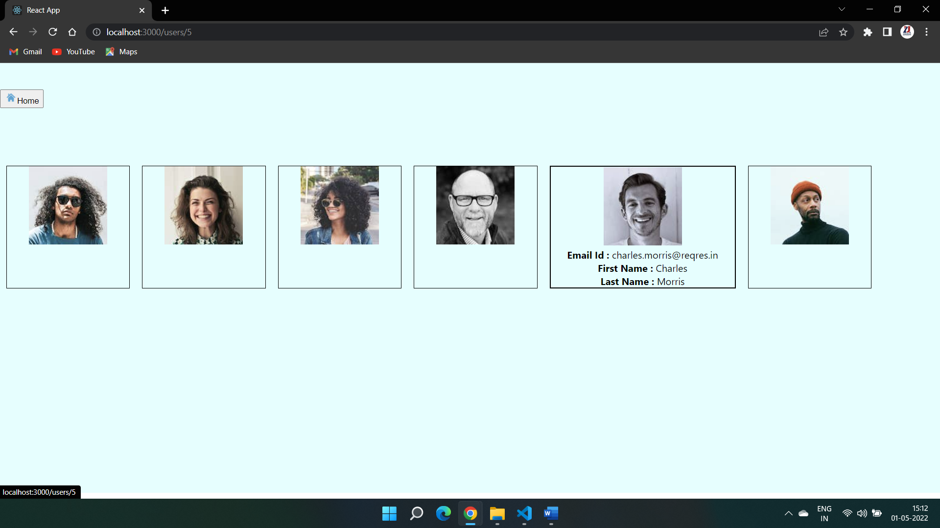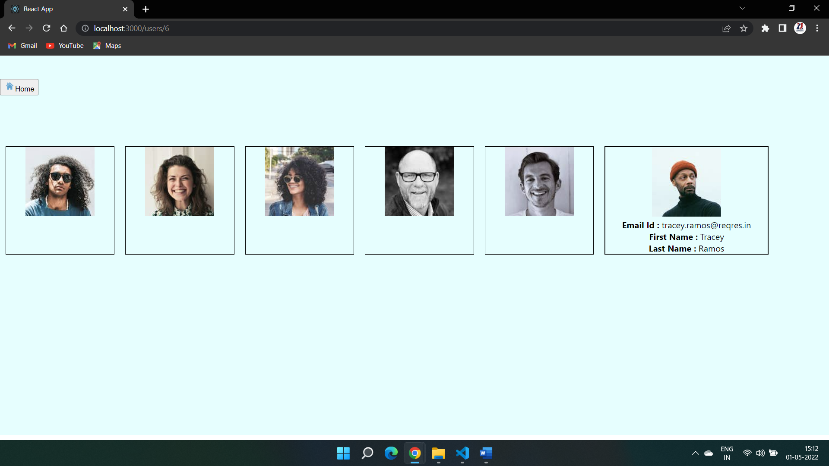

Home button is for enrouting the user to home Page.

Resources of Home Page:

import React, { Component } from 'react'

import axios from "axios"

import { Link } from 'react-router-dom'

export default class HomePage extends Component {

    constructor(props){

      super(props);

      this.state={

          user_details:[]

      }

    }

    async componentDidMount(){

        let response = await axios.get("https://reqres.in/api/users")

       console.log(response,response.data,response.data.data)

       const details=response.data.data;

       this.setState({

           user_details:details

       },()=> console.log("state",this.state.user_details))

    }

  render() {

    return (

      <>

      <br></br><br></br><br></br><br></br><br></br><br></br><br></br><br></br><br></br><br></br><br></br>

      <div style={{display:'flex',flexDirection:'row'}}>

          {this.state.user_details.map((user)=>{

              return <div key={user.id} style={{border:'2px solid',width:'300px',margin:'10px'}}>

                 <Link to={`/users/${user.id}`}><img src={user.avatar}></img></Link>

                 <div><b>Name : </b>{user.first_name} {user.last_name}</div>

              </div>

          })}

      </div>

      <br></br><br></br><br></br><br></br><br></br><br></br><br></br><br></br><br></br><br></br><br></br><br></br><br></br>

      </>

    )

  }

}

Resources of User Page:

import React, { useEffect, useState } from 'react'

import { Link, useParams } from 'react-router-dom'

import axios from "axios"

export default function UserDetails() {

    const [userDetails, setUserDetails] = useState([]);

    const params = useParams();

    useEffect(() => {

        let response = axios.get("https://reqres.in/api/users").then((res) => {

            const details = res.data.data;

            console.log(res)

            setUserDetails(details);

        })

        console.log(userDetails, params.userid)

    }, [])

    return (

        <>

        <br></br><br></br>

        <div  style={{height:'50px',textAlign:'left'}}> <Link to={`/users`}><button><img src='https://www.rawshorts.com/freeicons/wp-content/uploads/2017/01/blue_repicthousebase_1484336386-1.png' style={{width:'20px',height:'20px'}}></img>Home</button></Link></div>

        <br></br><br></br><br></br>

        <div style={{ display: 'flex', flexDirection: 'row' }}>

            {

                userDetails.map((user) => {

                    if (user.id == params.userid) {

                        return <div key={user.id} style={{ border: '2px solid', width: '300px', margin: '10px' }} >

                            <div><Link to={`/users/${user.id}`}><img src={user.avatar}></img></Link></div>

                            {

                                <div>

                                    <div><b>Email Id : </b>{user.email}</div>

                                    <div><b>First Name : </b>{user.first_name}</div>

                                    <div><b>Last Name : </b>{user.last_name}</div>

                                </div>

                            }

                        </div>

                    }

                    else {

                        return <div key={user.id} style={{ border: '1px solid', width: '200px', margin: '10px' }} >

                            <div><Link to={`/users/${user.id}`}><img src={user.avatar}></img></Link></div>

                        </div>

                    }

                })

            }

        </div>

        <br></br><br></br><br></br><br></br><br></br><br></br><br></br><br></br><br></br><br></br><br></br><br></br><br></br><br></br><br></br>

        </>

    )

}

THANKING YOU

***THE END***